Semiannual Cube Test

In order to minimize the conjecture and inherent human bias while attempting to logically troubleshoot a technical problem, TSD created a process to check for gross ( **+/- 2%** ) dimensional errors in our milled and printed products. The finished 1cm ( 10mm ) cube shall have a ( X, Y, and Z axis ) measurement of **no higher than 10.2mm** and **no lower than 9.8mm**. This test is meant to confirm gross dimensional errors and should – ideally -- follow a report of dimensional defects of three or more cases from the finishing department.

The test will change in sophistication in time. For now, we simply follow one of two processes to test the respective lines.

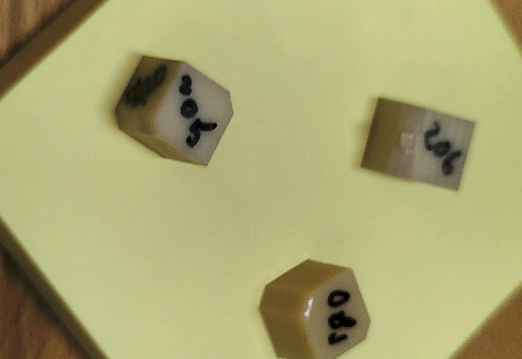

In milling, this test should be performed either semiannually or when three or more cases have been noted in finishing that originated from the same mill and/or sinter oven. The test is meant to test the entire path from nesting through sintering. We simply nest the test file stl in a puck (even with other crowns) and proceed with normal flow. THIS IS ONLY A DIMENSIONAL TEST. Shade, texture, and other characteristics will not be assessed with this test. If we require the test to be completed prior to bringing up a downed mfg line, the test file should be nested solo and sintered on hyper speed to better facilitate prompt analysis.

Search for this file:



In printing, this test should be performed either semiannually or when three or more cases have been noted in finishing that related to potentially defective models. We simply nest the test file stl in the printer in question (even with other models), and proceed with normal flow.

The file will either be on the desktop or on the print room thumb drive.

Upon completion of the 1 cm cube, it should be measured with high quality calipers from milling or the print room.

Please note that a passing measurement only clears the machine in question of gross dimensional errors at the time of the test. No calibration should take place prior to the test or it negates its usefulness.

Operators will be responsible for documenting which machine(s) were utilized in the test and below is an example of the data expected:

**Objet 1cm cube:**

Expected Z - __10 mm Actual Z - __9.99 mm_

Expected Y - __10 mm Actual Y - __9.98 mm_

Expected X - __10 mm Actual X - _10.05 mm_

**Roland 205 1cm cube:**

Expected Z - __10 mm Actual Z - _10.01 mm_

Expected Y - __10 mm Actual Y - __9.99 mm_

Expected X - __10 mm Actual X - __9.97 mm_

**Roland 206 1cm cube:** *\*\*\*cal’d immediately before test*

Expected Z - __10 mm Actual Z - __9.98 mm_

Expected Y - __10 mm Actual Y - __9.96 mm_

Expected X - __10 mm Actual X - __9.97 mm_

This test is now deployed and will have improvements added incrementally by multiple parties in the future. Please document additions accordingly upon gaining consensus from the team.